**Using Logistic Lasso Regression and Ego Networks to Model Synergy in League of Legends**

**II. Introduction**

Electronic Sports (esports) is a sports category that includes video game competitions. With its popularity increasing over the last few years, following the outbreak of the pandemic, esports have been attracting more and more players, among different age groups, for a variety of games. The most popular genres associated with esports are multiplayer online arena (MOBA), first-person shooter (FPS), and real-time strategy (RTS). One of the most famous MOBA games is League of Legends. Developed by Riot Games, it was first released in 2009, it has been dominating the world of MOBA games with currently, on average, more than 150 million monthly players.

A typical game in League of Legends includes two teams of five players each selecting unique champions with diverse abilities to engage in strategic and competitive matches on the Summoner's Rift map. The game progresses through phases, including early, mid, and late game, where teams aim to destroy the enemy Nexus by overcoming turrets, inhibitors, and powerful neutral objectives. Players earn gold and experience by defeating minions, monsters, and enemy champions, using these resources to enhance their champions through item purchases.

Extensive research has been conducted over the years in the field of esports analytics. This paper is an extension of the prior work of Lee, Ramler, and Schuckers regarding the symbiotic relationships between champions in the game. Over the years, players have formulated a strategy, commonly referred to as metagaming (Carter, Gibbs, and Harrop 2012). In LoL, metagaming strategy (also known as meta) is a product of the wisdom of the crowd, and it has stabilized into a team of five unique roles:

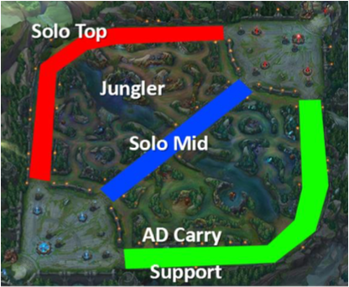(Solo) Top, Jungle, (Solo) Mid, Attack damage carry (aka “ADC”), and Support. All these different roles are required to distribute themselves among three lanes in the Summoner’s Rift map, as it can be seen in Figure 1

Figure 1 Summoner's Rift map with meta role distribution

AD Carry and Support are the only two meta roles that share the same lane. Therefore, their cooperation is vital for the success of the team. However, this cooperation is heavily reliant on the performance of the two champions selected for these roles.

Inspired by this study and a similar project on a different game called Clash Royale, this research aims to investigate the synergistic relationships between champions in those two roles, employing Logistic Lasso Regression and Ego Networks to model and analyze the impact on game performance metrics. This project not only serves as a valuable exposure to esports analytics but also lays the groundwork for future academic pursuits, allowing me to explore the intersection of my passion for esports and analytical skills within the field of sports analytics.

🡪 I am interested in grad school: determinant for grad school and strengthen my applications, more competitive for grad programs

**II. Project Approach/Design/Methodology**

**In this section of your proposal you will describe how you will accomplish the goals you delineated in the introduction. As above, the questions below do not need to be addressed in any particular order, but should be integrated into a thoughtful, cohesive and clear narrative.**

**-Using terms that a general audience can understand, describe the approach, design, or methods you will use to complete the project.**

We have an existing database, interact with it, pull the appropriate data, lasso regression stuff: zeroing out coefficients, ridge regression, introducing that little bit of bias in the coefficients, lasso is appropriate because we have so many interconnected terms in our models, and zero’s out the insignificant terms

**-Are there any foreseeable obstacles that you might encounter while working on this project? If so, how will you address these?**

Models might not work well if we overwhelm them, plenty of ways to scale back the structure, and we might not be able to fine-tune the model enough to understand the mechanisms in the game (large p values instead of small)

**--What resources are needed for the project to be completed successfully? Comment on the availability of these items at SLU. If any items need to be purchased, be sure to itemize these in an Appendix at the end of the proposal.**

Supercomputer, hpcc, R, Rstudio, access to the database, all these are free and Dr. Ramler can give me access to. Nothing needs to be purchased.

**III. Appendices:**

**- Appendix A Literature or Resources Cited: Complete references to any scholarship cited in your proposal should appear here.**

**- Appendix B Project Timeline: Using a narrative or tabular format, briefly outline your weekly goals for progress on your project. Describe what a typical work day on this project will be for you. Will you be working primarily in a studio, the library, a lab? What types of specific things will you be doing? It is expected that you will work 40 hours per week on your project, and your timeline should reflect this. Please explain whether and why you plan to deviate from this requirement.**

**-Appendix C Level of Preparation for the research proposed. List: Skills/technique/knowledge needed to complete the project. Describe any relevant classes and grades received; other experience (laboratory work, internship, etc.)**

Stat 113, 213, 289, 234, 334, CS 256, Machine Learning